
 
37
^{th}
International Conference on Learning Disabilities
Las Vegas, NV; October 2015
Sheri Berkeley
Len Annetta
Stacia Stribling
George Mason University
Thismaterialisbaseduponworksupporte
dbytheNationalScienceFoundation
underGrantNumber:DRL-1420448.Anyopini
ons,findings,andconclusionsor
recommendationsexpressedinthisma
terialarethoseoftheauthor(s)anddo
notnecessarilyreflecttheviewsoftheNationalScienceFoundation.
- Creating Success for Students with Learning Disabilities in
Science (poster #46) o Leigh Ann Kurz, Peggy King-Sears, Sheri Berkeley
- Learning Progression in Science: Implications for Students with Learning Disabilities (poster #47)
  - Marina Shapiro, Amanda Luh, Len Annetta

- Promoting Self-regulation of Students with Learning
Disabilities within Project-based Learning (poster #48) o Anna Menditto, Aubrey Whitehead, Sheri Berkeley
- Tales from a Gate-keeper: Strategies for Successful Research
Partnerships in K-12 Schools (poster #49) o Mary Rehberg, Stacia Stribling
- Interactive Papers Friday 10/2, 8:30-10:15 Cohiba 5
- Although highly capable, limited numbers of students with LD are pursuing careers in STEM fields, even though many work-related opportunities are available to these individuals (Basham & Marino, 2013).
- Because acquisition, retention, and demonstration of science knowledge can pose multiple challenges for students with LD, researchers have noted a critical need to foster students’ ability to self-regulate their own learning (e.g., Brigham, Scruggs, & Mastropieri, 2011).
- Existing self-regulated learning (SRL) work primarily focuses on well-defined and/or discreet tasks, while less is known about the role of self-regulation in complex, long-term learning tasks (Schunk & Zimmerman, 2003; Bernacki, Nokes-Malach, & Aleven, 2015).
- Students with learning disabilities are an ideal sample for this type of work precisely because
  - these students characteristically display inappropriate causal attributions for learning (e.g., Baird, Scott, Dearing, Hamill, 2009; Tabassam & Grainger, 2001), and
  - these attributions are malleable (e.g., Berkeley, Mastropieri, & Scruggs, 2011; Miranda, Villaescusa, & Vidal-Abarca, 1997).
- How do student effort attributions for learning influence their perceptions of self-efficacy during a project based learning activity (creation of a serious educational game–
SEG)?
  - What types of goals do students with LD set during a science project (SEG creation) and why do they self-report making those choices?
  - How self-efficacious are students with LD toward related tasks (SEG creation, science learning)?
  - What are attributions for success and failure of students with LD on related tasks (SEG creation, science learning)?

- Screening criteria:
  - Eligibility for special education services for a learning disability
  - No secondary disability in the areas of attention or behavior (e.g., ADHD, EBD)
  - IEP goals in at least one language-based area
(language, reading, writing)
- 11 students participated: o 4 sixth graders
    - (female = 3, male = 1) o 4 seventh graders
    - (female = 2, male = 2) o 3 eighth graders
    - (female = 3)
- IQ o M = 88.5
- Reading Comprehension o 3rd - 48th percentile
- Word Reading
  - 1st - 25th percentile
- Math
  - 1st - 42nd percentile

Complex project-based science activity  Phase 1:
  - Science instruction
  - Advantages and disadvantages of renewable energy (solar & wind)
- Phase 2:
  - SEG Planning
  - Storyboarding - scenes, characters, and actions to promote player learning of science content
- Phase 3:
  - SEG Creation
  - Building, problem solving, and revising the SEG based on selfevaluation and instructor feedback

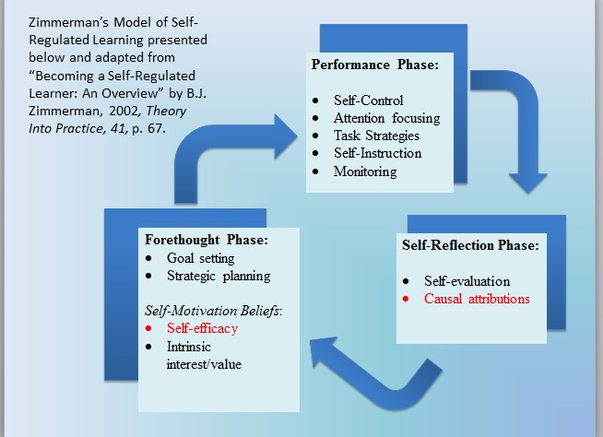

Goal Setting and Reflection  Phase 1:
  - Setting a purpose for goal setting and reflection
“When people learn new things, it helps them learn more if they set goals for what they want to accomplish, and then think (or reflect) on their efforts. This helps them to make really good goals and to accomplish and learn more!”
  - Modeling of goal setting and reflection
- Phase 2:
  - Guided practice of goal setting (prior to work session) and reflection (after work session)
- Phase 3:
  - Independent practice of goal setting (prior to work session) and reflection (after work session)
PHASE I | PHASE II | PHASE III
Goal Setting (modeling) | Goal Setting (guided practice) | Goal Setting (independent practice)
Science Instruction | SEG  Planning | SEG  Creation
Reflection (modeling) | Reflection (guided practice) | Reflection (independent practice)

- Microanalytic Protocols

Observations
(Schunk & Zimmerman, 2011) o Primary data source o Students were interviewed twice
during work sessions
    - prior to work session
    - after work session o Questions prompted students to talk about
    - goals they set to guide their work
    - progress toward that goal,
    - their attributions for what they attributed their success or failure during the work session
    - how they would change their goal for the next work session
  - Work sessions were observed and
coded to capture
    - interactions with the researchers/instructor and among students in the instructional group
    - student verbalizations of selfregulation (including attributions and/or self-efficacy)
- Science learning measures o Pre- and post-tests o Informal assessment of planning documents and student SEGs
- Pre- and Post Project Interviews o Student perceptions of science
learning, interest

Project Activities |  | PHASE I |  | PHASE II |  | PHASE III
Primary  Data  Sources | - Student IEP & demographics  - Achievement measures  (reading, math, attention)  - Pre-interview  - Science pretest |  | • Science posttest | • Qualitative MAP  interviews (short version) | • Plan selfevaluation  & interview | • Qualitative MAP  interviews (full version) | - Game selfevaluation  & interview  - Post-  interview
Secondary  Data  Sources |  | - Observation  (daily)  - Student notebooks |  | - Observation  (daily)  - Student notebooks |  | - Observation  (daily)  - Student notebooks | • Student game

  - What types of goals do students with LD set during a science project and why do they self-report making those choices?
- Initial Finding:
  - Students set product oriented goals rather than process oriented goals (which is consistent with the literature for LD students)
Example 1:

RQ1:
Researcher: So tell me something that you plan to work on today.
Student: I am planning to work on my introduction and go on to event 1.
Researcher: Intro and event 1. Can you show me where that is in your plan?
Student: Well here’s my introduction and in my intro all I have to do is get my characters to talk and event 1 I just need to make people move.
Researcher: Let’s talk about the intro first. What things will you need to do accomplish that goal today?
Student: Put the characters down.
Example 2:
Researcher: Tell me something you plan to work on today.
Student: My characters.
Researcher: Can you grab your binder because I want you to show me some stuff. Can you show me in your plan where that is? Where your characters are? Either the map or something you wrote on. So which characters?
Student: Well I named the teddy bear Bob and I have a girl who is a kid and I need a girl or boy. I have a cop.
Researcher: So what things will you need to do to accomplish this goal?
Student: Uh, well the characters.
Example 1:
o How self-
efficacious are students with LD toward related tasks?
 Initial Finding:
o Self-efficacy statements did not seem to match student self-evaluations of their
performance
Researcher: Ok, you said you did really well with the making questions and the characters. How confident are you in yourself that you can succeed with this in the future? like on a scale of 1 to 5

RQ2:
Student: I would say a 3
Researcher: Why do you say a 3?
Student: I’m pretty sure I believe we have a lot more things to accomplish by this
Example 2:
Researcher:…so, how sure are you that you’ll be able to make acceptable progress towards an A+ game on a scale of 1-5.
Student: I’d have to say a 3.
Researcher: Why do you think 3?
the links and stuff.
Student: Um because last time we were on the computer I already started
o What are
attributions for success and failure of students with LD on related tasks?
 Initial Finding:
o Many students struggled to (or couldn’t) explain why they succeeded or failed
Researcher: What did you accomplish today?

RQ3:
Student: most of the beginning of um, my game. I have to finish a few adjustments because I got them [turbines] stuck in the ground and I have to get that out. Then I have to set up the questions and that’s about it. And then I work on the next level and then finish that one and then work on the last level. Then I’m done.
Researcher: So did you meet the goal you set for yourself today?
Student: yeah, uh hum. I just have to fix that one problem with the talking and that’s it.
Researcher: OK so why do you think you succeeded?
Student: I really don’t know.
Researcher: you don’t know? Well what were some of the things you did to help yourself meet your goal?
Student: Um … [long pause]
Researcher: Well you said you were going to finish most of your design and the beginning of your environment, set up your farm. So how do you think you were able to succeed at doing those things?
Student: I worked faster and tried to um get rid of most of the details so it wouldn’t take so long.
- Expectation
o Self-regulation of
science learning
(content) or o Self-regulation of SEG
development (skills)
- Initial Finding o Self-regulation of engagement
Example 1:
Researcher: What did you do help yourself accomplish your goal?
Student: I didn’t talk to my friends. I paid attention and focused.
Example 2:
Researcher: So did you meet the goal you set for yourself today? [student shakes head] Yes you did. You sure did. Why do you think you succeeded today?
Student: Because I got through everything I needed to get through and I didn’t think that I was going to get to the last part, the introduction, but I did.
Researcher: And why do you think you were able to?
Student: Because I stayed focused and didn’t talk or didn’t look around or I just stayed focused.
Researcher: And what other strategies did you use?
Student: Stayed focused.
Researcher: Any others?
Student: Mmmm not really that’s probably it. Stayed focused.

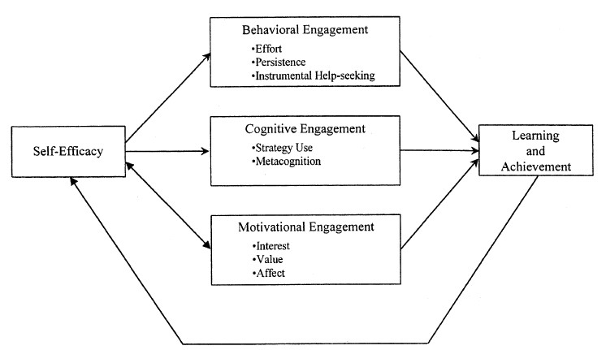
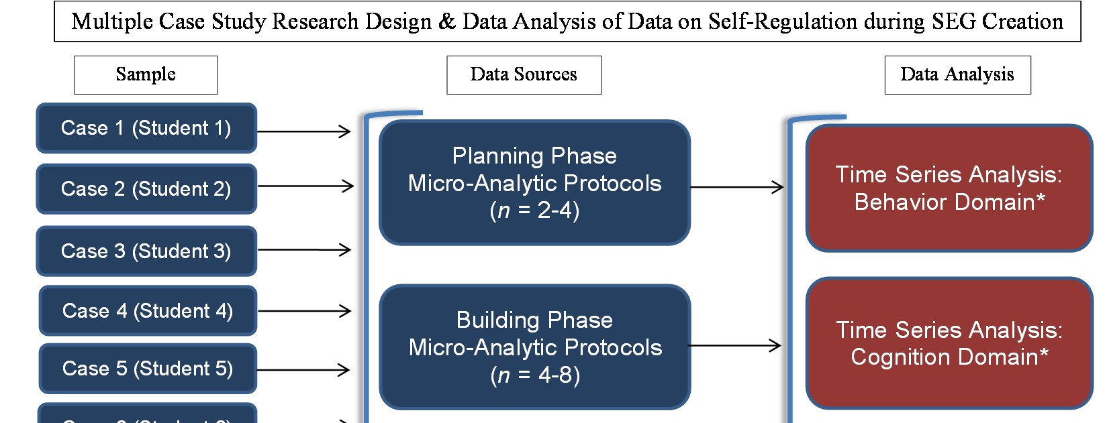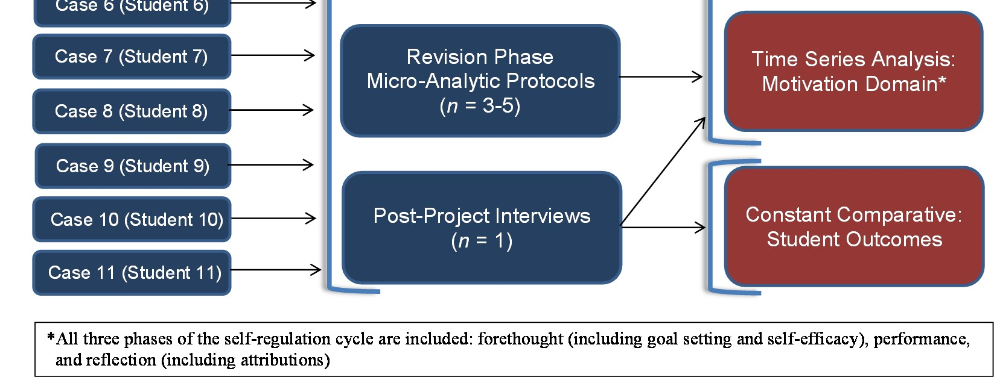

Data Analysis Organization for Self-Regulation Data
Case #1 (repeat for each case)
Data Source | Forethought / Goal Setting | Self-efficacy | Performance | Reflection | Attribution
TIME 1 (Short MAP)
TIME 2 (short MAP)
.
.
.
TIME X (Full MAP)
.
.
.
TIME X (Revised MAP)
.
.
.
TIME X (PostInterview)
- Baird, Scott, Dearing, Hamill, 2009
- Basham & Marino, 2013
- Berkeley, Mastropieri, & Scruggs, 2011
- Bernacki, Nokes-Malach, & Aleven, 2015
- Brigham, Scruggs, & Mastropieri, 2011
- Linnenbrook & Pintrich
- Miranda, Villaescusa, & Vidal-Abarca, 1997
- Schunk & Zimmerman, 2003  Schunk & Zimmerman, 2011
- Tabassam & Grainger, 2001
- Yin
- Zimmerman, 2002




